**Chirag H M-6373750(superset id)**

**Week 2 JUnit hands on:**

**Exercise 1 & 2: Setting up Junit and writing basic Junit test case**

Create new maven project.

Next add the following dependency in the pom.xml file

<dependencies>

<dependency>

<groupId>junit</groupId>

<artifactId>junit</artifactId>

<version>4.13.2</version>

<scope>test</scope>

</dependency>

</dependencies>

**Create a New Test Class**

* Right-click on the src/test/java folder.
* Name it MyFirstTest.

Output and code of the sample test case.

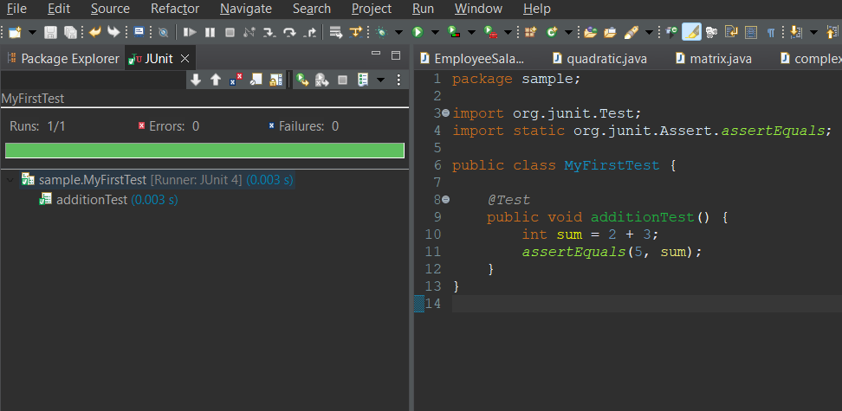

**Exercise 3: Assertions in Junit**

package sample;

import org.junit.Test;

import static org.junit.Assert.*;

public class MyFirstTest {

*@Test*

public void testAssertEquals() {

*assertEquals*("Check sum", 10, 5 + 5);

}

*@Test*

public void testAssertNotEquals() {

*assertNotEquals*("Check not equal", 12, 5 + 5);

}

*@Test*

public void testAssertTrue() {

*assertTrue*("Should be true", 10 > 5);

}

*@Test*

public void testAssertFalse() {

*assertFalse*("Should be false", 5 > 10);

}

*@Test*

public void testAssertNull() {

String str = null;

*assertNull*("Should be null", str);

}

*@Test*

public void testAssertNotNull() {

String str = "JUnit";

*assertNotNull*("Should not be null", str);

}

*@Test*

public void testAssertSame() {

String s = "hello";

String t = s;

*assertSame*("Both references should point to same object", s, t);

}

*@Test*

public void testAssertNotSame() {

String a = new String("hello");

String b = new String("hello");

*assertNotSame*("Different object references", a, b);

}

*@Test*

public void testFailExample() {

try {

int x = 5 / 0;

*fail*("Exception was expected");

} catch (ArithmeticException e) {

// Expected exception

}

}

}

**Output:**

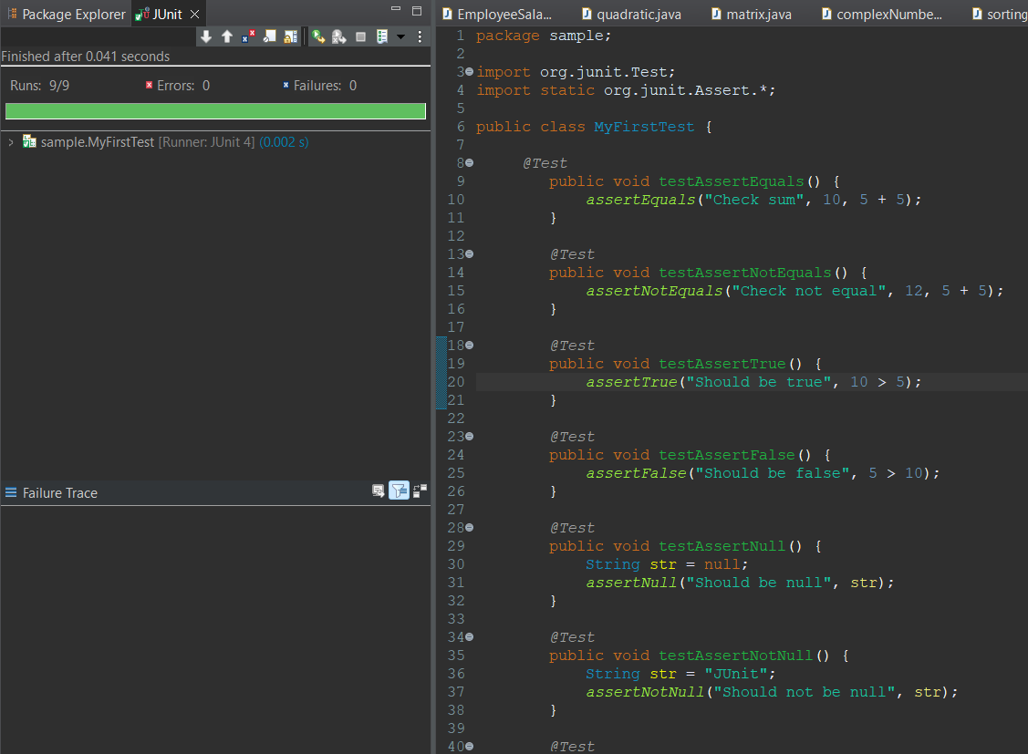

**Exercise 4:**

**Arrange-Act-Assert (AAA) Pattern, Test Fixtures, Setup and Teardown Methods in Junit**

Let’s say we have a simple Calculator class:

package sample;

public class calculator {

public int add(int a, int b) {

return a + b;

}

public int subtract(int a, int b) {

return a - b;

}

}

JUnit Test Class Using AAA Pattern & Setup/Teardown:

package sample;

import org.junit.After;

import org.junit.Before;

import org.junit.Test;

import static org.junit.Assert.*;

public class CalculatorTest {

private calculator Calculator;

*@Before* // Setup method

public void setUp() {

Calculator = new calculator(); // Arrange: Initialize before each test

System.***out***.println("Setup before test");

}

*@After* // Teardown method

public void tearDown() {

Calculator = null; // Cleanup after each test

System.***out***.println("Teardown after test");

}

*@Test*

public void testAddition() {

// Act

int result = Calculator.add(5, 3);

// Assert

*assertEquals*(8, result);

}

*@Test*

public void testSubtraction() {

// Act

int result = Calculator.subtract(10, 4);

// Assert

*assertEquals*(6, result);

}

}

**Output:**

